

Name: - Tejas Parghi

Student ID: - 21505016

Course: - MSc Health informatics

Module: - Knowledge Management

Subject code: - CP70016E

Tutor: - Parisa Saadati

Topic: - The integrated knowledge management maturity model.

Table of contents: -

1. Motivation…………………………………………….3
2. Relation of knowledge management…….3
3. Paper review…………………………………………3
4. Critical analysis of the paper………………….4
5. Conclusion…………………………………………….5
6. References…………………………………………….6
7. Motivation: -

With standing the truth that many enterprises around the world are the use of information control (KM) strategies, there may be no broadly generic method for determining where an enterprise stands in assessment to its competitors. **There had been numerous expertise management maturity models produced, but they're all so distinctive that the instruction in reality calls for a regularly occurring and standardised information control adulthood model.** the majority of the fashions have one thing in commonplace: they are all built on the equal KM elements and use one-of-a-kind maturity stages to decide maturity. The goal of choosing the model is to create a general or framework for destiny knowledge control opinions.

1. Relation with knowledge management: -

The crucial related purpose of the sort of model is to evaluate understanding manipulate in businesses and provide feedback on in which they stand in assessment to their opposition. it is almost difficult to manage data because the maximum valuable asset without this type of framework. KM adulthood essentially tells us in which we are and what regions we want to decorate with a purpose to raise and capitalise at the possible competitive advantage. The interpreted relation objectives can be categorized as per below description.

* To seize information - KM repositories let you reach this intention. Memos, reports, shows, and articles can be established documents with embedded expertise that will be saved in a style that allows them to be quickly retrieved.
* To Facilitate information switch between individuals and companies — to improve understanding get entry to among people and companies.to improve the knowledge environment by means of proactively encouraging and profitable the improvement, switch, and alertness of understanding.
* To manage information as an Asset – some agencies account for their highbrow capital on their balance sheets, even as others use their know-how belongings to generate new sales or cut charges from their patent portfolio.

Paper review: -

The aim of this paper is updated offer an evaluation of present-day expertise control technologies and programs (KM). The significance strain of company Intranets within the international marketplace enlargement of information control merchandise, systems, and commercial enterprise applications, as well as updated the worldwide diffusion of KM practises.  
  
The discussion starts by reviewing the core standards and enterprise dreams of understanding management. Then it will be displaying why the rise of company Intranets is compatible with the modern-day adulthood of KM merchandise and practises. Following that, we will discuss modern trends in the KM enterprise for products and solutions. ultimately, case research of positive firms which have efficiently implemented KM are presented. (Serna M., E. (2015)).

for plenty companies, this period of rapid technological development is likewise a length of consistent opposition to hold an aggressive benefit. expertise, after labour, land, and capital, is virtually turning into the biggest element of manufacturing. internal understanding is hard to duplicate, even though a few types of highbrow capital are transferrable. which means that if personnel cease the business enterprise, the information they have got stored in their heads can be lost. As an end result, the number one goal of control is to improve facts acquisition, integration, and application procedures, that's precisely what knowledge management (KM) is all about. (Wang, S., Noe, R.A. and Wang, Z.-M. (2011)

the overall issue with knowledge control theory is that it's far defined differently by way of distinctive teachers. consistent with, the principle is divided into two streams of concept. the primary is discovered to be extra humans-centred, while the second one is determined to be greater generation-targeted. while digging deeper into the literature, we stumble upon even greater competing theories, but within the widest experience, expertise management can be defined as the capability to use understanding to achieve organisational goals.

Critical analysis of paper: -

The following paper illustrates that such performance indicators can help win budgetary support for KM implementation, as well as assess implementation success, provide feedback on implementation, and draw lessons for future implementation. However, the measures of KM systems are critical for understanding how such systems should be built and implemented, as well as providing a means for an organisation to compare itself to competitors. An organisation can see what has to be done in order to get a competitive advantage by doing so. declare that measuring knowledge is really important. A full theory of knowledge or knowledge assets is difficult to build without an accurate measurement. As a result, there has been no noticeable progress in treating knowledge as a variable to be explored or studied. (Wang, S., Noe, R.A. and Wang, Z.-M. (2011).

The reasons for organising the maturity degree of knowledge management are akin to the ones for determining the efficacy, efficiency, or results of KM tasks in widespread. a reference model could help establishments in reaching a success KM effects based on organised and consequently similar revel in received by means of others. We chose a method similar to that utilized by Serena M.E to outline commercial enterprise system orientation maturity considering it's far a comparable idea that allows establishments assess their cutting-edge situation and plan their future activities. (King and Marks, 2008).

KM strategy, KM user education, leadership support, business process reengineering, knowledge networks, dissemination and transfer of knowledge, organisational climate, pilot projects, capturing and revision of knowledge, organisational knowledge architecture, macro environment, use of information technology tools for KM, people, measuring the effects of KM, quality assurance, and marketing are among the assessed critical success factors.

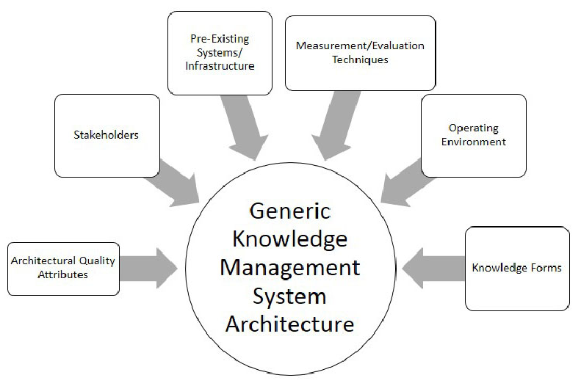

Figure 1:- Knowledge Management system architecture.

By conducting factional interpretation, it can be clearly considered that Successful knowledge management strategies should: Determine the goal of the KM programme (internal vs. external focus and which type of internal focus) Break the information hoarding cycle (intentional and non-intentional). Information hoarding can occur as a result of a lack of mechanisms for sharing information or a failure to recognise that the information may be useful to someone in another department. (Wang, S., Noe, R.A. and Wang, Z.-M. (2011).

provide the capacity to personalize and alter the product over the years to make certain increase and flexibility. Manage the person base by way of taking both heavy and mild users under consideration. the answer ought to be capable of organise the information in order that it's miles most beneficial to the individual searching for statistics. for example, I might love it to offer me with statistics this is applicable to my gift stage of knowledge, making it easier for me to realize. furthermore, some customers might be ones for whom KM is their process, even as others will really best statistics clients. Ascertain that era serves as a facilitator as opposed to an alternative choice to human understanding and intelligence. (King and Marks, 2008).

Conclusion: -

To conclude the discussion, The overall understanding is described as "knowledge stored in humans’ thoughts and used to make choices in unexpected conditions." even as efficient know-how need to be within the mind of a knowledge worker (or computerized system), dormant or brief expertise may be preserved (i.e., in paper or digital format) for retrieval and alertness via the knowledge employee. The argument is that facts need to be implemented to a brand-new circumstance as a way to be useful in making decisions or taking moves. it is critical to apprehend the distinction among knowledge and information. those are separate entities. at the same time as 'information' stored in a laptop device isn't always an especially rich provider of human interpretation for feasible motion, 'information' is discovered inside the consumer's subjective context of motion. The discussed concept is a overall subset for the integrated matured knowledge management practices which can be deploy effectively in an individual organisation.

References:-

1. Serna M., E. (2015). Maturity model of transdisciplinary knowledge management.

*[online]* m.e (8AD). *Summon 2.0*. [online] uwl.summon.serialssolutions.com. Available at: https://uwl.summon.serialssolutions.com/search?s.q=knowledge+management&op=Search# [Accessed 12 May 2022].

‌

1. Wang, S., Noe, R.A. and Wang, Z.-M. (2011). Motivating Knowledge Sharing in Knowledge Management Systems. *Journal of Management*, 40(4), pp.978–1009. doi:10.1177/0149206311412192. [Accessed 27 april 2022]
2. King, W.R. and Marks, P.V. (2008). Motivating knowledge sharing through a knowledge management system. *Omega*, 36(1), pp.131–146. doi:10.1016/j.omega.2005.10.006. [Accessed 27 april 2022]



Name: - Tejas Parghi

Student ID: - 21505016

Course: - MSc Health informatics

Module: - Knowledge Management

Subject code: - CP70016E

Tutor: - Parisa Saadati

Topic: - The integrated knowledge management maturity model. (Elem 1)

Group name: FIVE GUYS

**INTRODUCTION**: -

The following textual content presents a step-by means of-step guide to growing an information control system the use of the MediaWiki expertise management platform. The wiki is meant to help remote places students who are coming to the United Kingdom to have a look at at UWL. Outlining the information management method, functional and non-purposeful device necessities, understanding capture criteria, and an evaluation of 3 open-source tools that could be utilised to create this kind of machine were all a part of the development. The machine evaluation and layout were then defined in detail, accompanied by means of the system's very last implementation. There are device screenshots protected. at the stop of the textual content, there is a end segment as well as a mirrored image on the implementation.

-----------------------

The assignment on which the group has been operating has the goal of giving beneficial expertise to international students and is based on the understanding management concept defined above. The the rest of this paper covers the market research the institution conducted to be able to set up the requirements for the understanding management gadget, the method the organization used, the functional and non-functional requirements, an evaluation of 3 viable gear the group should use and motives for why the tool selected was chosen, details of the gadget analysis and design, an evaluation of the task's achievement, and a few concluding feedback.

The open-source software application MediaWiki is used to create wikis. The Wikimedia undertaking, the non-income Wikimedia foundation, and lots of other wikis, inclusive of websites4, utilise it under most of the people License (GPL).  
Daniel Mayer, a Wikipedia contributor, got here up with the call MediaWiki. all and sundry can update the contents of the wiki, and the brand-new content material may be read right away after saving the modifications. it is also a content material control system (CMS), Bulletin Board machine (BBS), Groupware, Messaging, or computer Supported Cooperative paintings (CSCW) software, in addition to a Workflow management machine (WfMS)5.  
in the meanwhile, MediaWiki makes use of the Apache web server to provide internet pages, the MySQL database gadget to shop content material, and the personal home page script language to attach those additives.

knowledge is the build-up of data received from personal enjoy and various studies over a period of time. This in reality approach that it can be a set of statistics, guidelines, heuristics, numbers, and different records. knowledge can be separated into categories: specific know-how and tacit know-how.  
Tacit knowledge is understanding that is derived thru real-existence studies. for instance, emotional know-how, abilities, insights, hunches, and so on. explicit expertise, alternatively, is knowledge that is said in phrases and numbers.  
The know-how received via books, wikis, and different simply available documentation.

Research work: -

due to the current epidemic of 2020, many individuals have grown to be privy to the importance in their health and feature made it a concern. humans everywhere in the global are now completely privy to the catastrophic results which can result in deadly diseases and health troubles (Brunier and Drysdale, 2022). anybody has all started to preparation right cleanliness, visit the gymnasium, consume a well-balanced eating regimen, and observe a healthful regimen that consists of exercise and yoga, among different matters (emblem, Timme and Nozrat, 2020). We started with the aid of asking participants questions on the health industry at random (interviews with open-ended inquiries), together with whether they were acquainted with sure medicines.

SWOT analysis: -

**Strength** - people are privy to the scenario and are interested in mastering more about it.  
**Weak spot** - there's no unmarried place where all fitness and health facts can be discovered. all of the facts are scattered among more than one web sites.  
**Opportunities** - Create a software program software for each category that consists of distinctive records approximately the subtopics for customers.  
**Danger** - whilst the software program software is finished, it could now not meet the users' expectancies.

The evaluation of survey: -

The primary data collection: -

1. 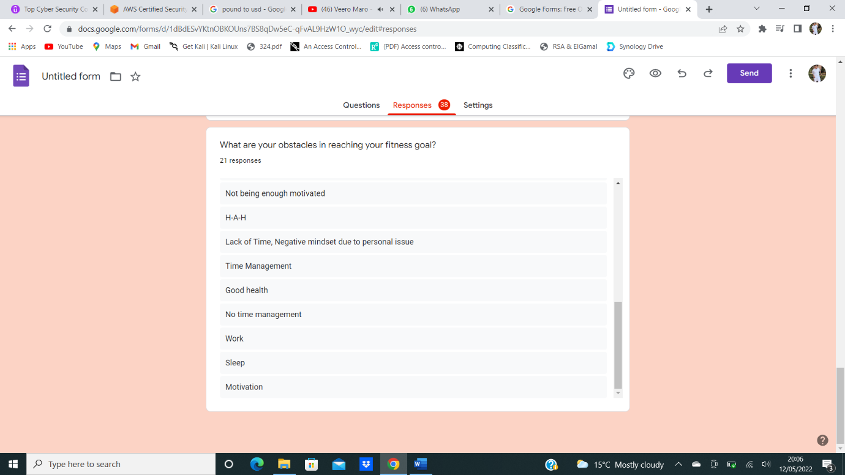
2. 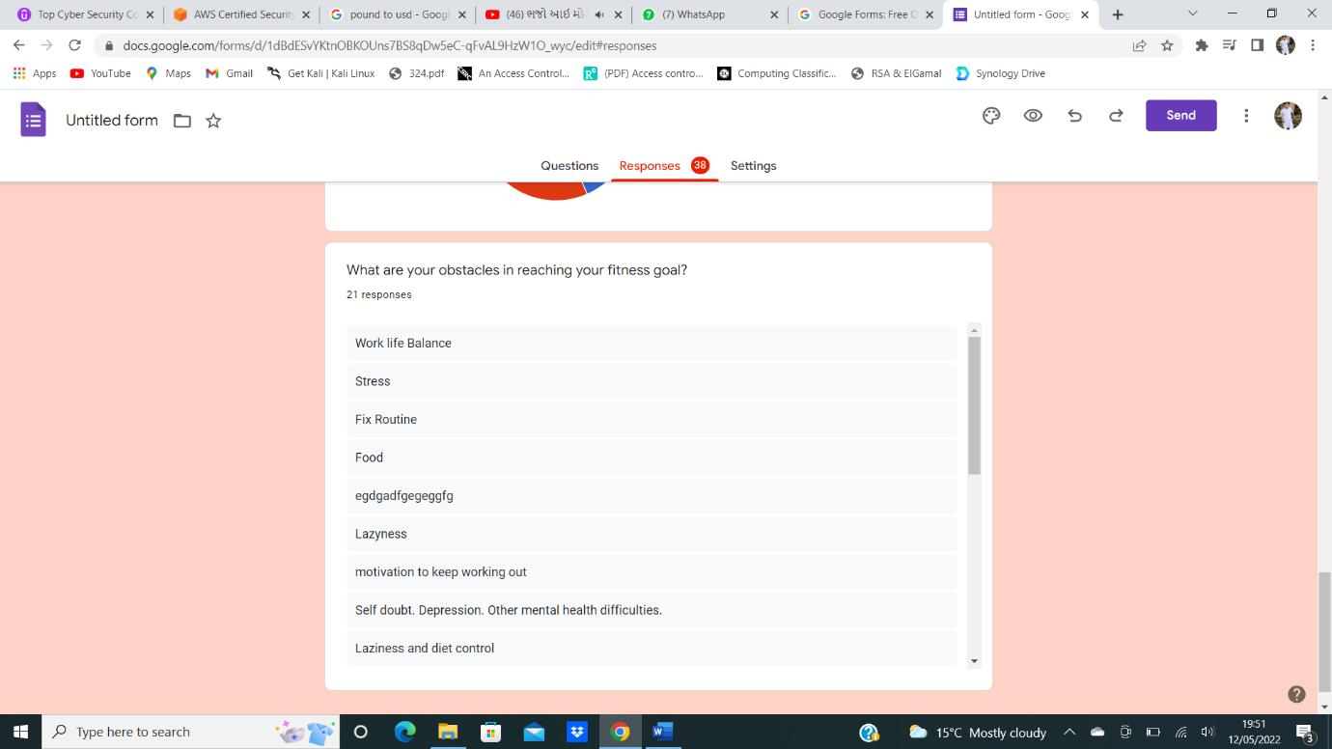
3. 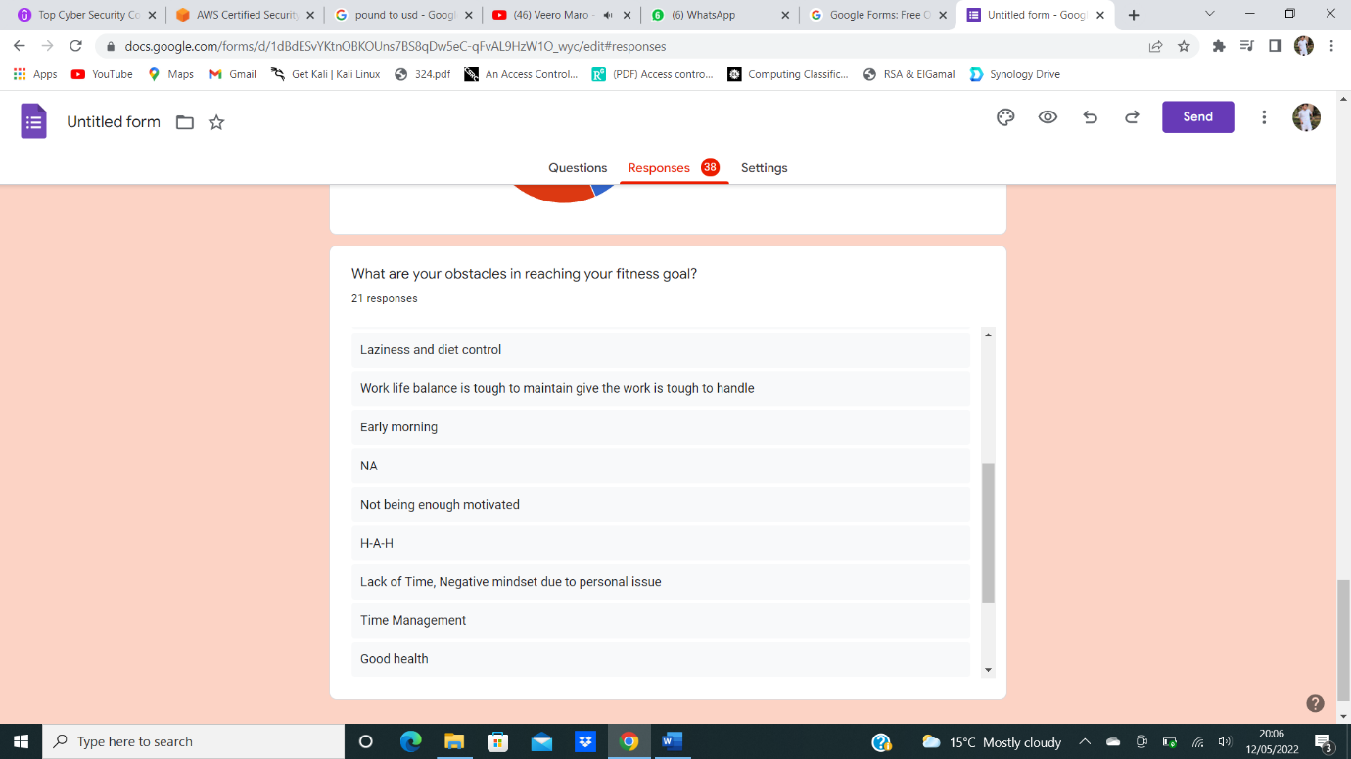

By collecting data from above’s survey question, we had started data gathering and commencing data analysis. The survey had been successfully implemented and generated by the help of google forms.

The responses which were received are below,

















the primary requirement for our expertise control gadget become to create a gadget that had all of the data in one area. different vital wishes consist of the gadget's availability and simplicity of access for give up customers. It should assist numerous languages due to the fact customers might also come from various corporations, have a chat discussion field, and help graphics, photographs, films, and different media. It ought to first cover as a minimum the number one troubles in health and health, as well as predominant subtopics if possible.

Tool evaluation: -

we have determined that MediaWiki is the best alternative for our case observe. For our KM software program, we to start with in comparison WordPress, Mediawiki, and phpMyFAQ.  
All three programmes are loose to use and run at the Apache web server, with MySQL serving as the content material database. furthermore, they aid a spread of running structures which include mac, home windows, and linux in maximum conditions without problem and are available globally. whilst we compared the three programmes, we located that MediaWiki is the maximum superb for us, as the alternative had been ineffective at performing complex queries and have been insecure in terms of safety. The content material of these internet pages is saved inside the MySQL database gadget, and the utility runs on the Apache web server to provide webpages.  
subsequently, the Hypertext Preprocessor scripting language is employed to attach the two additives. each article permits readers to put up a word in the discussion container at the lowest of the page, making the wiki greater participatory. in this technique, a person can be notified of adjustments to articles and who made them, as there can be an electronic mail cope with associated with the comments, which can be used to have an intelligent discussion approximately the problem among the numerous users involved. to a degree, MediaWiki additionally aids in the prevention of spam and vandalism. moreover, it supports multiple languages, allowing users from all around the global to browse the wiki of their desired language. In phrases of safety, it restricts positive permissions to sure users, which includes permitting simplest signed-in customers to edit pages whilst non-signed-in users can most effectively see them, and plenty of greater features.

MediaWiki Implementation:-

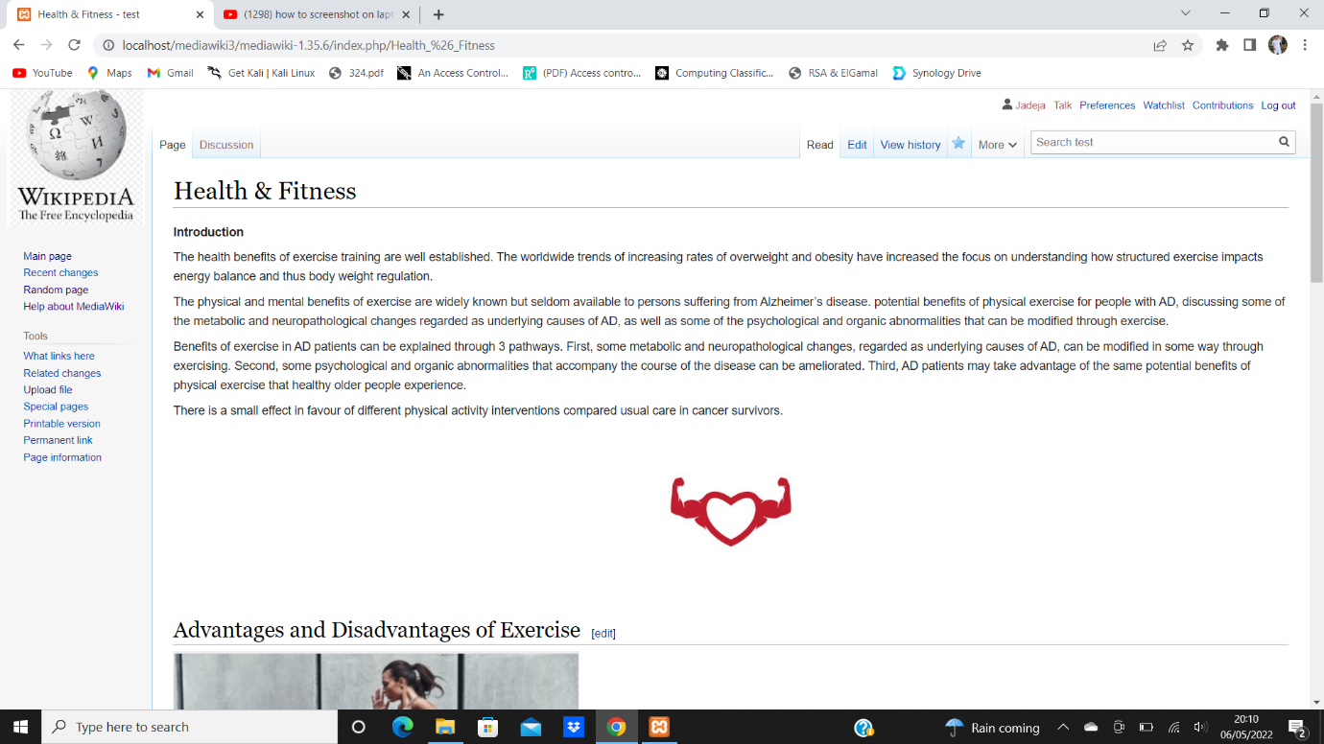

Main page with topic and sub-link as well.

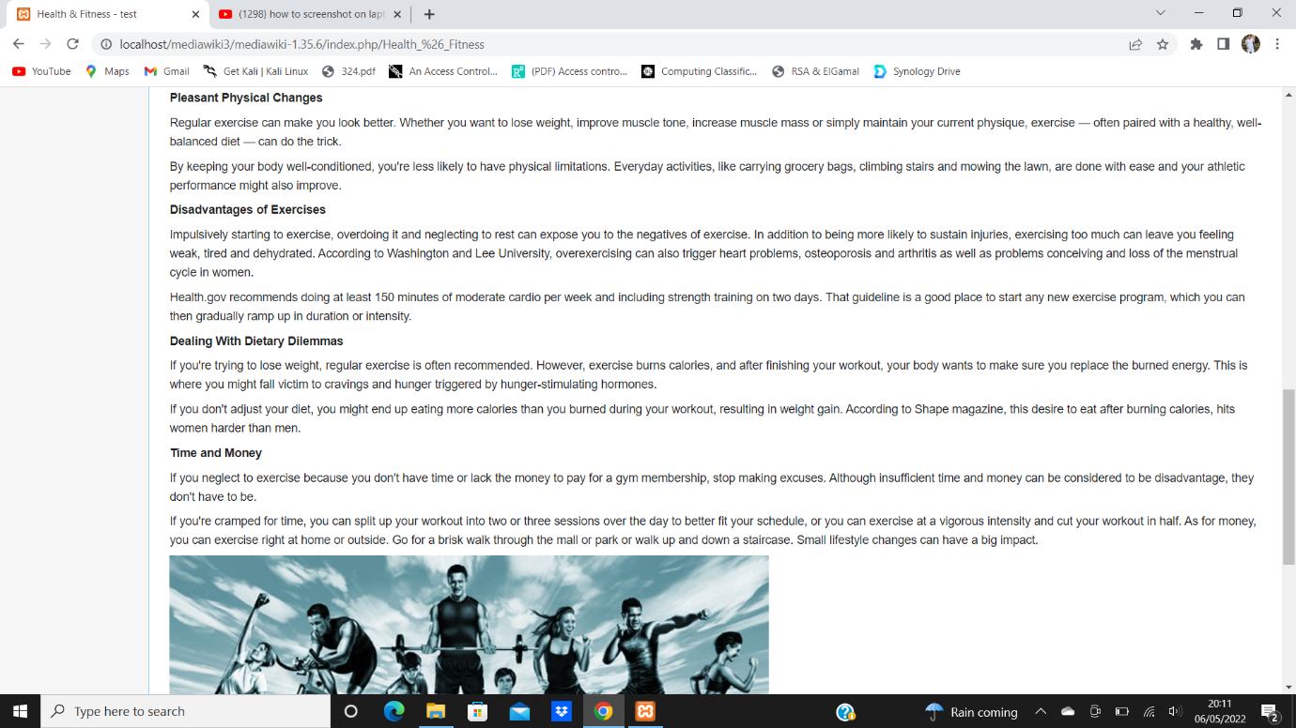

* Health Occupations page

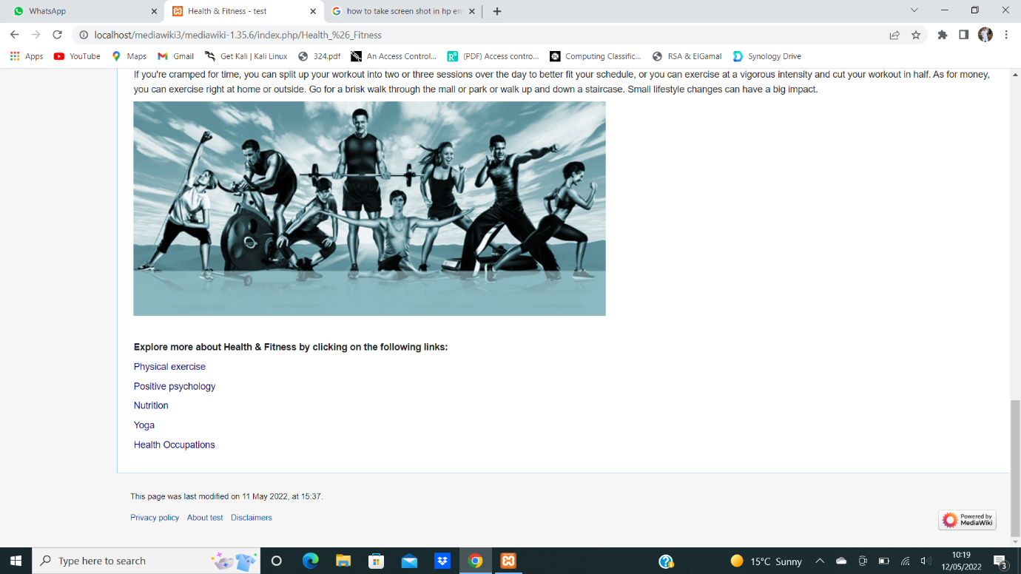

* Health Occupations page

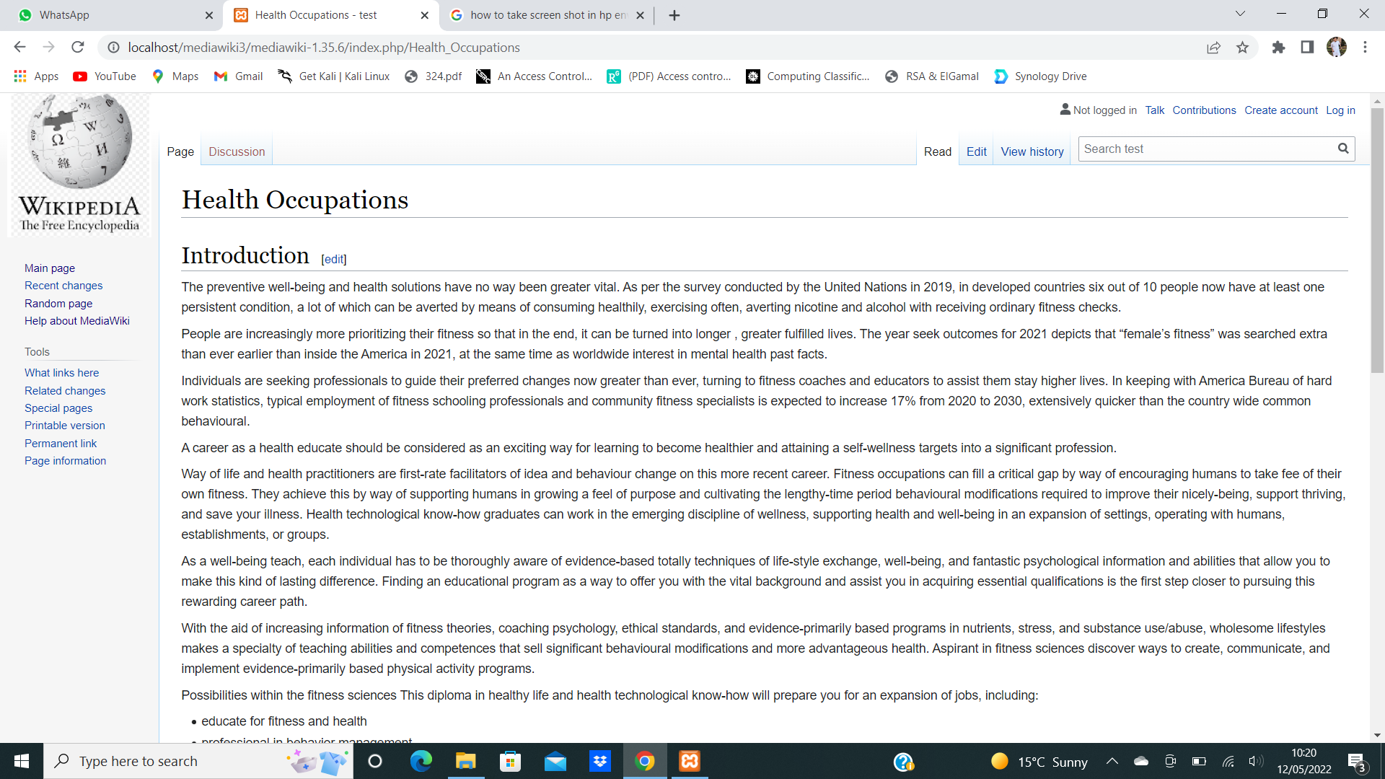

* Nutrition Page

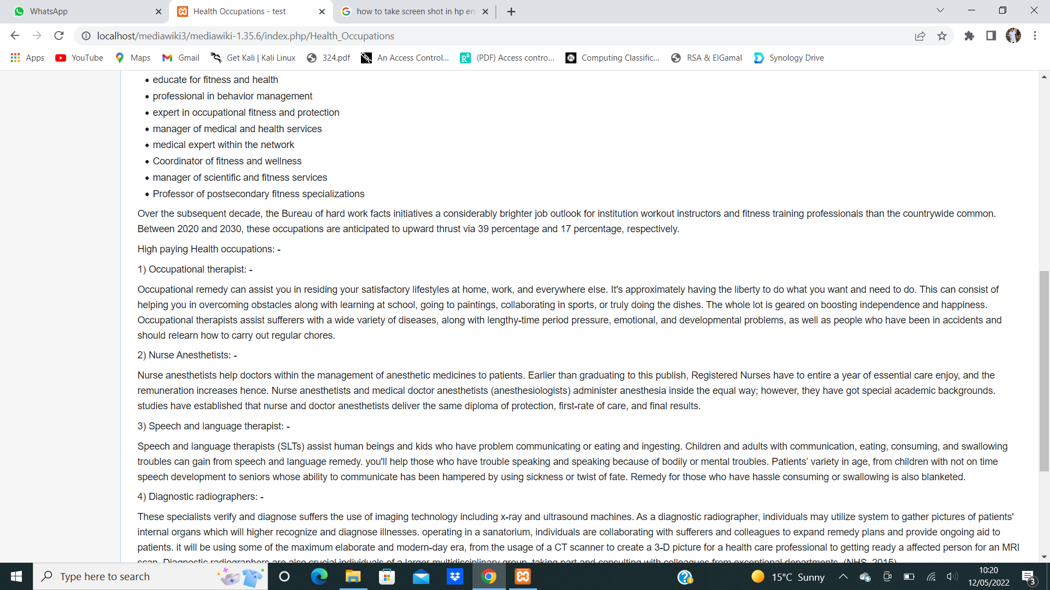

* Health Occupations: -

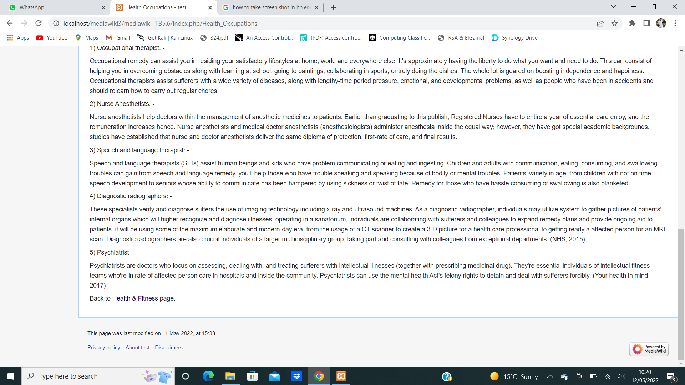

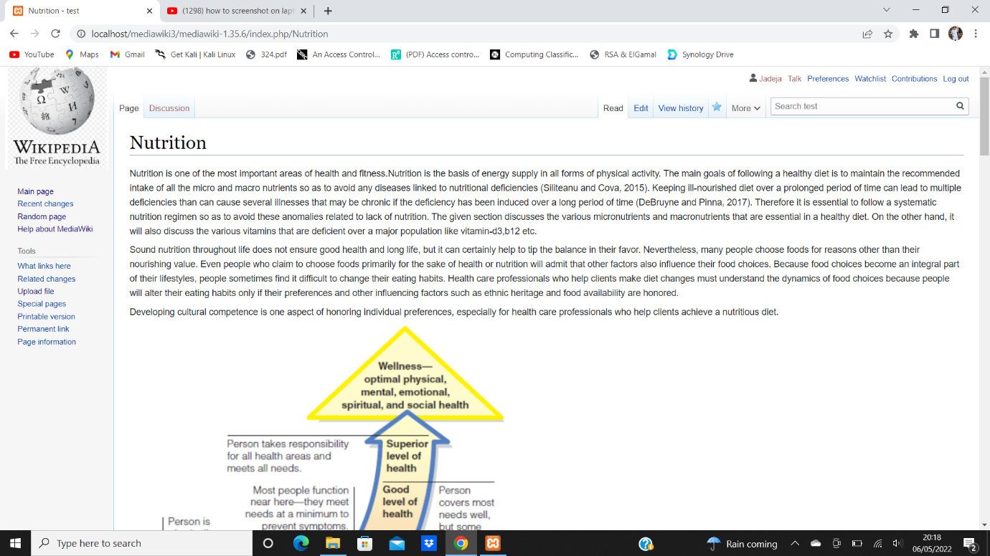

* Positive Psychology page: -

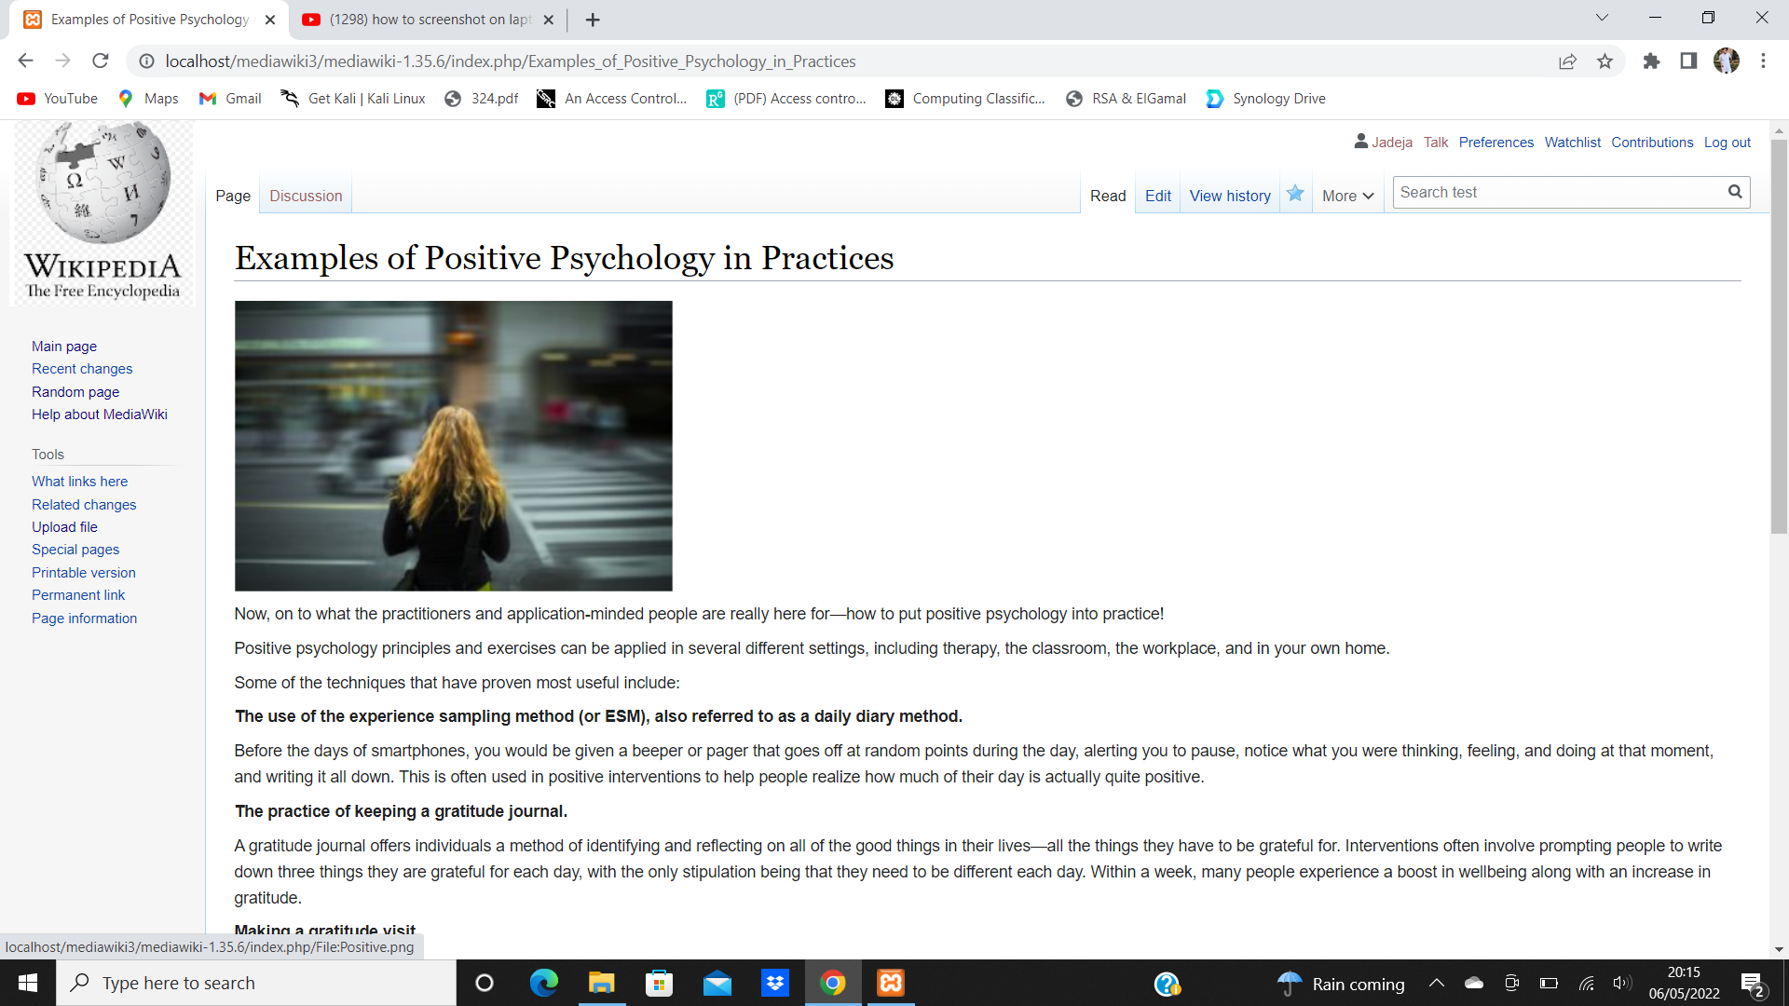

* Editing a Page



Conclusion: -

The predominant aim of this mission turned into to set up a gadget that could be used to elevate fitness and health attention, a system that would be without problems to be had and handy to the general public, and on which the relevant understanding will be observed without trouble. prior to operating in this subject matter, we performed marketplace studies and posted a bit questionnaire to examine what people reflect on consideration on the concern, and their remarks triggered us to pursue it. following a radical examination of know-how manufacturing tools, we selected the mediawiki platform due to its ease of use and person friendliness.

References:-

1. Serna M., E. (2015). Maturity model of transdisciplinary knowledge management.

*[online]* m.e (8AD). *Summon 2.0*. [online] uwl.summon.serialssolutions.com. Available at: https://uwl.summon.serialssolutions.com/search?s.q=knowledge+management&op=Search# [Accessed 12 May 2022].

‌

1. Wang, S., Noe, R.A. and Wang, Z.-M. (2011). Motivating Knowledge Sharing in Knowledge Management Systems. *Journal of Management*, 40(4), pp.978–1009. doi:10.1177/0149206311412192. [Accessed 27 april 2022]
2. King, W.R. and Marks, P.V. (2008). Motivating knowledge sharing through a knowledge management system. *Omega*, 36(1), pp.131–146. doi:10.1016/j.omega.2005.10.006. [Accessed 27 april 2022]

ss process reengineering, knowledge networks, dissemination and transfer of knowledge, organisational climate, pilot projects, capturing and revision of knowledge, organisational knowledge architecture, macro environment, use of information technology tools for KM, people, measuring the effects of KM, quality assurance, and marketing are among the assessed critical success factors.

KM strategy, KM user education, leadership support, business process reengineering, knowledge networks, dissemination and transfer of knowledge, organisational climate, pilot projects, capturing and revision of knowledge, organisational knowledge architecture, macro environment, use of information technology tools for KM, people, measuring the effects of KM, quality assurance, and marketing are among the assessed critical success factors.

KM strategy, KM user education, leadership support, business process reengineering, knowledge networks, dissemination and transfer of knowledge, organisational climate, pilot projects, capturing and revision of knowledge, organisational knowledge architecture, macro environment, use of information technology tools for KM, people, measuring the effects of KM, quality assurance, and marketing are among the assessed critical success factors.